 | MINISTRY OF EDUCATION AND TRAINING

FPT UNIVERSITY
Capstone Project Document
Gas selling support system
Design Document
GSS Team
Group Member | Nguyễn Xuân Quyết – 00818  Nguyễn Đức Vượng - 01067  Đinh Nho Hào - 00985  Nguyễn Huy Tuấn - 00986  Lê Thế Đại Dương - 01098
Supervisor | Mr. Phan Duy Hùng
Capstone Project code | GSS_v1.0

- Hanoi, May 16th 2012 -

The Table of Contents
A. Embedded System design 4
1. Design overview 4
2. Hardware Description 5
2.1. Caller ID Board 5
2.2. Caller ID board’s schematic: 6
2.3. Caller ID board’s PCB (Printed circuit board) 7
3. Embedded Software Description 8
3.1. Data flow Diagram 8
3.2. State Diagram 9
3.3. Description of Functions 10
3.3.1. Hardware uart module 10
3.3.2. Software uart module 10
3.3.3. Processing module 11
B. Software System design 12
1. Design Overview 12
2. System Architectural Design 13
3. Component Diagram 14
4. Detailed Description of Components 15
4.1. Component diagram 15
4.2. CRC Cards (Class-Responsibility-Collaborators) and Description 16
4.2.1. Customer 16
4.2.2. Customer Controller 16
4.2.3. Order 17
4.2.4. Order Controller 17
4.2.5. User 18
4.2.6. User Controller 19
4.2.7. Gas 20
4.2.8. Gas Controller 20
4.2.9. Supplier 21
4.2.10. Supplier Controller 21
5. Sequence Diagram 22
5.1. Manipulate data 22
5.2. Select data 22
6. User Interface Design 23
6.1. All-customer form 23
6.2. Edit form 24
6.3. Report Import/ Export 24
6.4. Sell Statistic 25
6.5. Call diary 25
6.6. Sale Statistic and Employee 26
6.7. Setup modem 26
6.8. Supplier list 26
6.9. Employee list 27
6.10. Import ourselves 28
6.11. Import from suppliers 28
6.12. Check repository 28
6.13. Notification: appear when someone is calling 29
7. Database Design or Data Structures 30

Embedded System design

Design overview
In First part of this Document, we will be presenting more about Embedded System (ES) of our Gas selling support system (GSS). After analyzing the problem, we had found two hardware solutions:
- Using a caller ID chip to receive data packet from telephone line and decode to phone number, after that transmit to PC through RS232 protocol. User must be using telephone to communicate with customers.
- Using module SIM to receive call signal, transfer incoming call’s phone number to PC through RS232; user can make and receive a call, send SMS to customer… User can connect microphone and speaker directly with module SIM to communicate with customers.
The document includes design of each solution include schematic, printed circuit board and code for microcontroller.

Module Telephone Caller ID:

Hardware Description

Caller ID Board
At this first solution, we discuss about telephone caller id board. Caller ID service could be registered with network provider, after the first ring of a receiving call, user will be received an extra data packet include information about the call: caller’s phone number, date and time of the call, and some network providers also send caller’s name.
The board’s normal mode is run at 9V voltage. This board will get data packet from telephone line after the first ring and decode to phone number by SM8223A and PIC16F876A. After decode to phone number, it will be transmitted to computer by serial communication port (RS232 protocol).

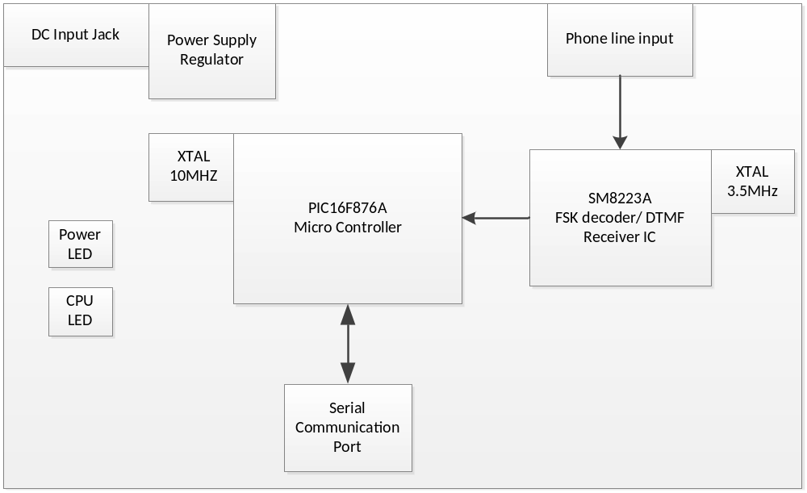

Figure 1: Caller ID board

Caller ID board’s schematic:
This is schematic of Caller ID board, it include components we are using and details about the wire between the components. The viewer will have an overview about our Caller ID board, it has been split to many parts, we can understand role of each part in the board.

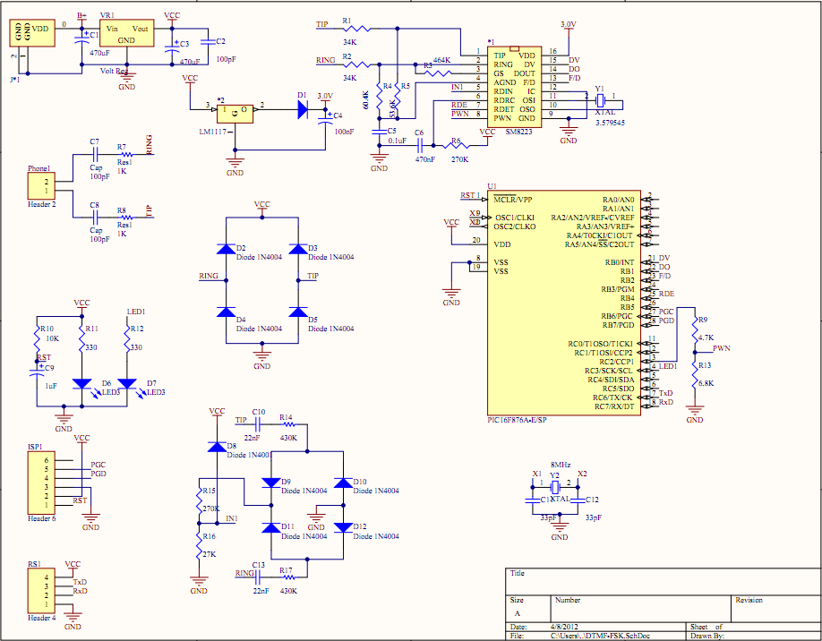

Figure 2: Caller ID board’s schematic

Caller ID board’s PCB (Printed circuit board)

The PCB includes electric components which we had been drawn in schematic and the wires used for connect components. In PCB, we can know exactly the size of the board for each component through pin map. After arranging position of components and wires, we can make real device with the size has been calculate before.

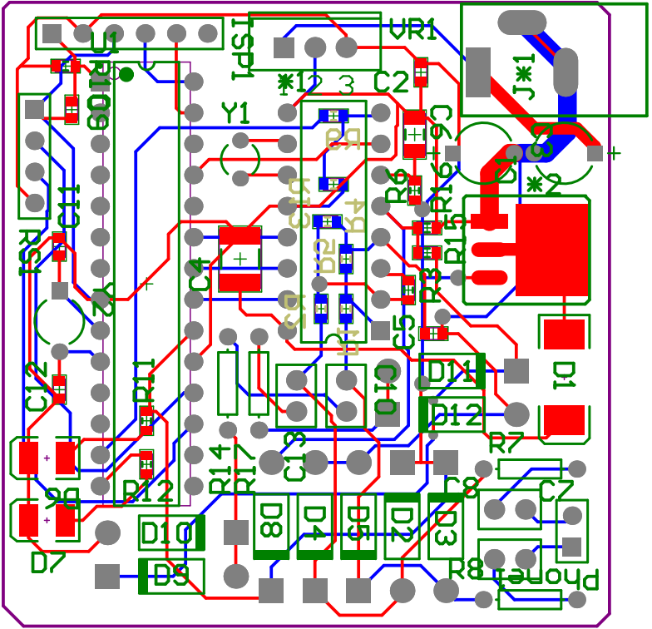

Figure 3: Caller ID board’s PCB

Software Description

Data flow Diagram

To begin, the power supply is turned on. After initializing components, the board will automatic enter standby mode and waiting for ring signal in telephone line. When there is no signal detected, the board will remain standby mode. SM8223A IC has a trigger pin, it will change the status from low to high each time ring signal detected, and this pin can wake up PIC16F876A µC. The board goes to normal mode.

The board is kept in normal mode and wait for data from telephone line. SM8223A will demodulate incoming data and transfer to PIC16F876A µC (both FSK and DTMF encoded signal). In PIC16F876A, it will be decoded to phone number and transmit to PC via RS232 protocol. Finally, the board returns to standby mode to save power and wait for other ring signal.

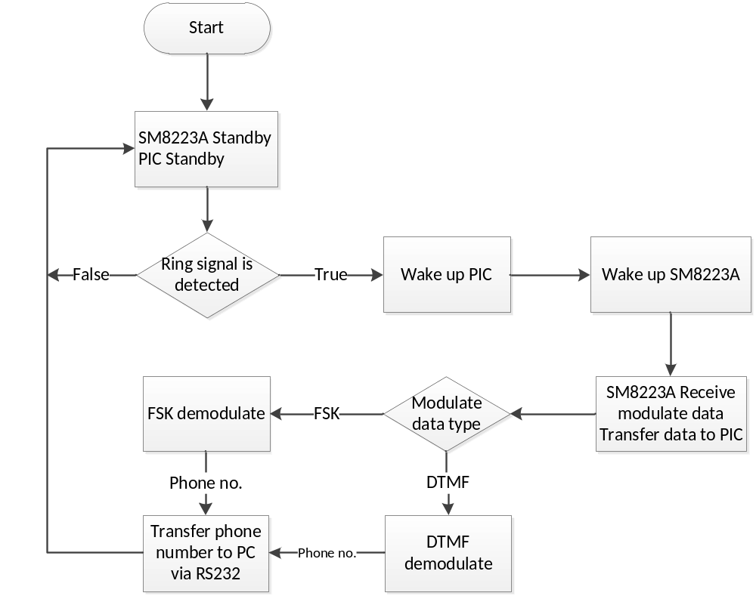

Figure 4: Dataflow diagram

State Diagram

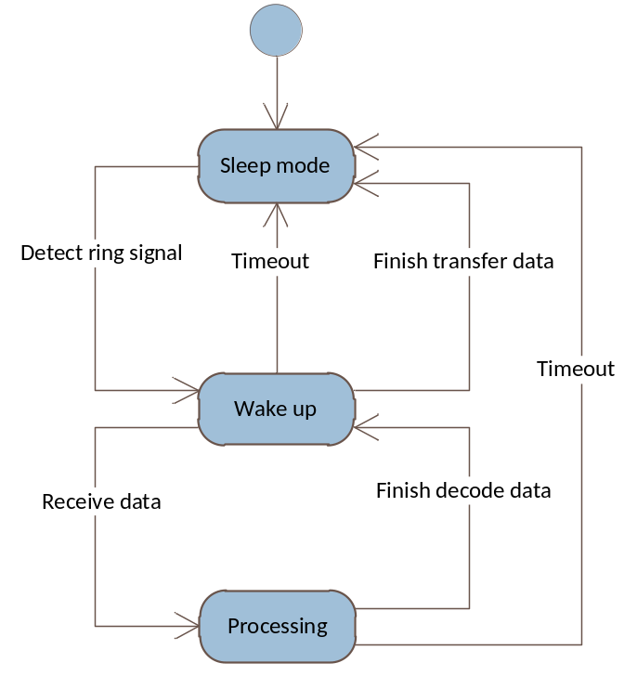

Figure 5: State diagram

Description of Functions
2.3.1 Hardware uart module

No. | Function Name | Parameter | Output | Description
1 | huart_init | N/A | N/A | This function makes initialize value for registers of uart protocol.
2 | huart_putc | char char_out | N/A | This function will send char_out character to PC through RS232 cable.
3 | huart_puts | const char* str_out | N/A | This function will push str_out string to PC through RS232 cable.

    - Software uart module

No. | Prototype | Input | Output | Description
4 | suart_getc | N/A | char | This function will get a character from data stream input and return this char to program.

    - Processing module
No. | Prototype | Input | Output | Description
5 | init_all | N/A | N/A | This function will initialize all variables, microcontroller’s pin status; enable interrupt before chips go to power down mode.
6 | receive_data | N/A | N/A | This function is used for receiving raw data from SM8223A.
7 | interrupt isr | N/A | N/A | This function will manage actions each time PIC has an interrupt.
8 | turn_led | bit led_status | N/A | Turn on led when start receive data and turn off when decoded data is sent.
9 | main | N/A | N/A | Main part of the program, this function will be executed when circuit is started.
10 | fsk_decode | unsigned char message[] | N/A | Decode data in message array and transmit to PIC through hardware uart module.

III. Module SIM908

Hardware Description

Module SIM908
At this solution, user need insert a SIM card to module and using microphone and speaker to communicate with the other as if a mobile phone. The module support user communicates with customer by some main functions: make and receive a call, send and receive message.
After receive ring signal from incoming call, this module will transmit phone number to PC through RS232 protocol automatically.
Module SIM908C supports many functions:
- The GSM base band engine
- The GPS engine
- Flash
- The GSM radio frequency part
- The antenna interface
- Other interface: SIM, UART, PWMs, I²C, LCD/SPI…
At this project we are going to use GSM functions (calling and SMS) only to log incoming call’s phone number, make a call and send news to customer by SMS.
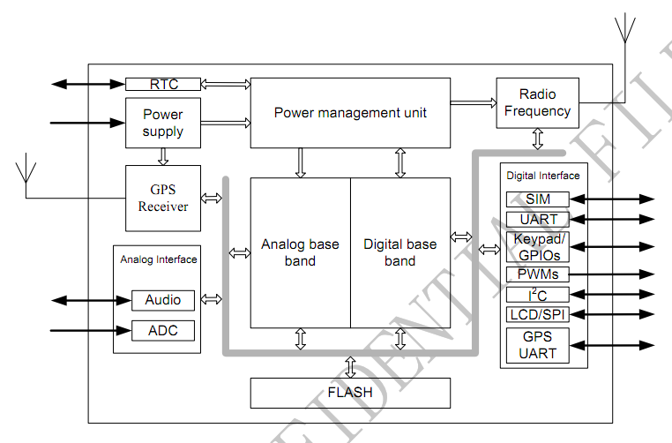
Figure 6: SIM908 functional diagram

Schematic
- Power supplier:
The board’s normal mode is run at 12v voltage. This partition will filter noise of source power and convert to many voltage levels suitable for others parts of the board.
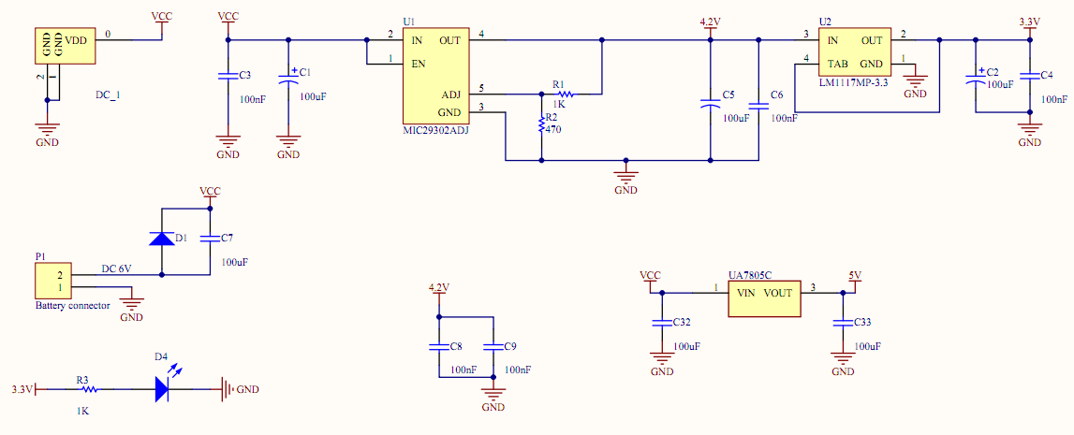
Figure 7: Power supplier schematic
- SIM908:
This is the main part of the project; IC SIM908 will receive the call signal and transmit to PC, beside it has audio interface which help user could accept the call and communicate with customer through a microphone and a speaker. The figure also represents reset button, SIM card holder and IC loud speaker volume.
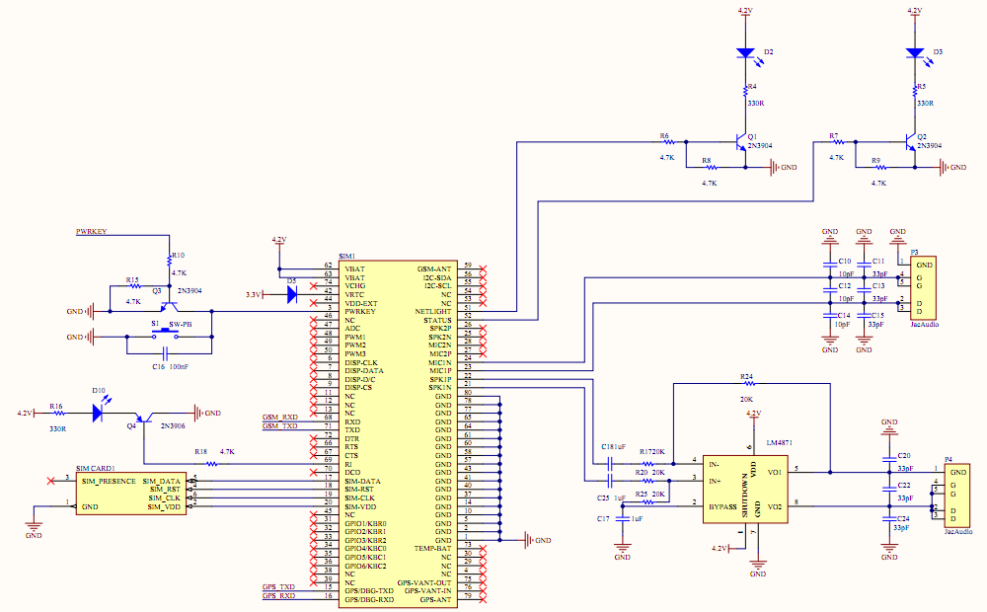
Figure 8: SIM908 schematic
- GSM-GPS led status:
This part includes 4 led display status of GSM and GPS signal.

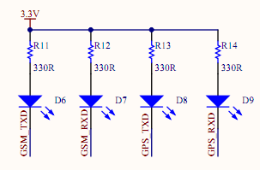
Figure 9: GSM-GPS led status

PCB (Printed Circuit Board)
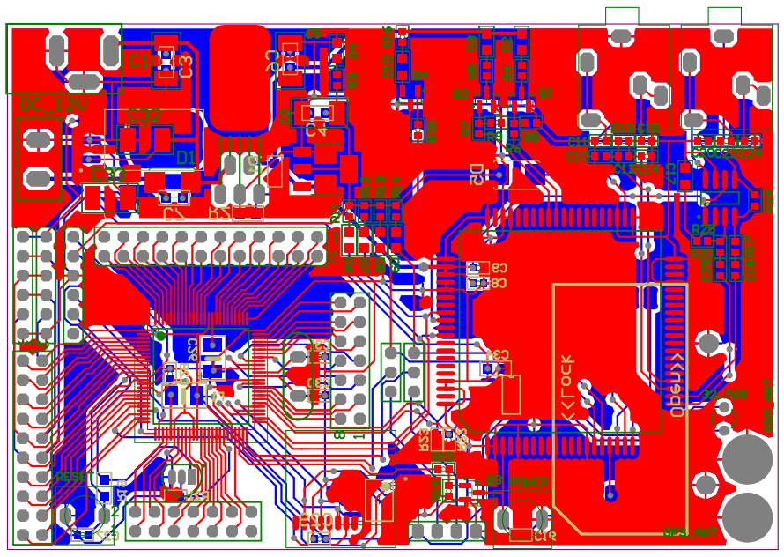
Figure 10: Printed Circuit Board

Software Description
Module SIM908C is controlled by AT command through RS232 protocol. After connect module with PC via serial port, we use a terminal connect to this port and send AT command to control it. At this capstone project we write a module connect with serial port and integrate to our software, so we can control the module by our software as well.
There are some AT command which we used in our project:
No. | Command | Description
1 | AT | Check state of the module
2 | AT+CLIP=1 | This command will set the mode of Calling Line Identification Presentation, after the RING signal, module will transmit identification of the phone number to serial port.
3 | ATA | Answer a call
4 | ATD | Make a voice call
5 | ATH | Hang up a call
6 | AT+CMGF | Select SMS message format
7 | AT+CMGS | Send SMS message
8 | AT+CLVL | Change volume of speaker

B. Software System design

1. Design Overview

Our Gas Seller System uses multi-tier design. Our multi-tier design contains three parts:

- View: Receives Input and display output for users. This part includes Form, UI component, sound and everything that interact with users. Based on role of user (admin, moderation, deliverer), the View display suitable UI. For example: Admin can add and remove orders but deliverer only can see the order.

- Control: translates user input into operations on the model. Execute function that modifies data from Model part. Check for securities access, database injection.

- Model: Manager Data check and give notification for users (for promotion event, user buying…) and respond error for admin.

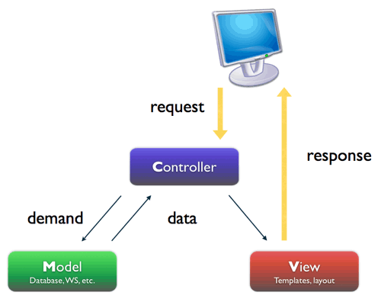

2. System Architectural Design
Choice of System Architecture
- Multitier architect.

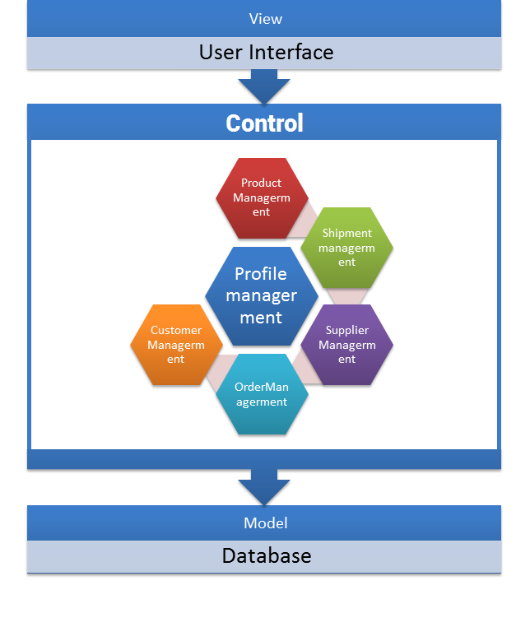
We consider some important attribute for our system:
Performance: It’s most important attribute of our system. With every database query, it should respond within 5 seconds. Program need to work correctly and never crash itself. Longest delay must be between Caller ID and computer, not communication between software’s components.
Usability: We build easy-to-use software for user with tree view like windows explorer. Separate list of users function and edit user details function. Use friendly color and component. With notifications function, users can reduce their effort for searching in database. Just sit in front of computer and drink coffee. Computer can do your work automatically.
Security: We created multi-roles software for some users. You can be admin and add more users, delete any records, make report and do anything you want. Password is stored by hash algorithm.

Component Diagram

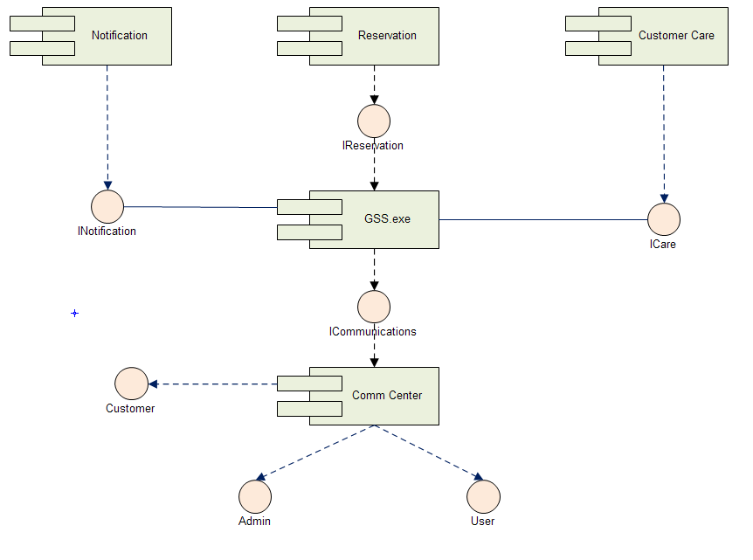

4. Detailed Description of Components

4.1. Component diagram

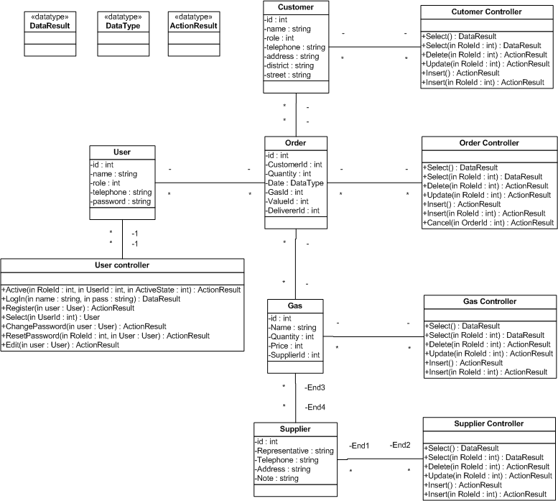

4.2. CRC Cards (Class-Responsibility-Collaborators) and Description

4.2.1. Customer

Customer
Responsibilities | Collaborator
- Keep information of customer. | - Order  - CustomerControler

No | Name | Type | Size | Constrain | Description
1 | Id | Integer | 128 bits | Unique | Unique Id for Customer
2 | Name | String | 100 characters | Only alphabet characters | Name of customer
3 | Telephone | String | No | No | Phone number of customer
4 | Address | String | 100 character, Except district and street | No | Address of customer
5 | District | String | 50 character | No | Address of customer
6 | Street | String | 50 character | No | Address of customer

4.2.2. Customer Controller

Customer Controller
Responsibilities | Collaborator
- Modify information of customer.  - Auto notify user when customer is approved to a promotion event.  - Auto create, select customer when someone is calling. | - Customer

No | Name | Parameter | Return type | Exception | Description
1 | Select |  | DataResult | NotFoundException | Search name of Customer
2 | Select | RoleId | DataResult | NotFoundException  RoleNotEnoughException | Search Customer
3 | Delete | RoleId | Action Result | NotFoundException  RoleNotEnoughException | Delete Customer
4 | Update | RoleId | Action Result | NotFoundException  RoleNotEnoughException | Update Customer
5 | Insert |  | Action Result |  | Insert Customer
6 | Insert | RoleId | Action Result | NotFoundException  RoleNotEnoughException | Insert Customer

4.2.3. Order

Order
Responsibilities | Collaborator
- Keep information of Order. | - OrderControler  - Customer  - Gas  - User

No | Name | Type | Size | Constrain | Description
1 | Id | Integer | 128 bits | Unique | Unique Id for Order
2 | CustomerId | Integer | 128 bits | Unique | Unique Id for Customer
3 | Quantity | Integer | 128 bits | Just Number | Number of gas
4 | Date | DateTime |  | After year 2011 | Date of order
5 | GasId | Integer | 128 bits | Unique | Unique Id for Gas
6 | ValueId | Integer | 128 bits | Unique | Unique Id for Value
7 | DeliverId | Integer | 128 bits | Unique | Unique Id for Deliver

4.2.4. Order Controller

Order Controller
Responsibilities | Collaborator
- Modify information of Order.  - Every user can make Order but only Admon can delete Order record. | - Order

No | Name | Parameter | Return type | Exception | Description
1 | Select |  | DataResult | NotFoundException | Search name of Customer order
2 | Select | RoleId | DataResult | NotFoundException  RoleNotEnoughException | Search Order
3 | Delete | RoleId | Action Result | NotFoundException  RoleNotEnoughException | Delete Order
4 | Update | RoleId | Action Result | NotFoundException  RoleNotEnoughException | Update Order
5 | Insert |  | Action Result |  | Insert Order
6 | Insert | RoleId | Action Result | NotFoundException  RoleNotEnoughException | Insert Order

4.2.5. User

User
Responsibilities | Collaborator
- Keep information of User | - UserControler  - Order

No | Name | Type | Size | Constrain | Description
1 | Id | Integer | 128 bits | Unique | Unique Id for User
2 | Name | String | 100 | Just characters | Name of user
3 | Role | Integer | 128 bits | Unique | Unique Id for Role (invidual, restaurent, family)
4 | Telephone | String | No | No | Phone number of customer
5 | Password | String | 32 character | No | Hash string of password

4.2.6. User Controller

User Controller
Responsibilities | Collaborator
- Manage information of User  - Password is stored as hash string.  - Only Admin can add and modify user information. | - User

No | Name | Parameter | Return type | Exception | Description
1 | Active | RoleId  UserId  ActiveState | ActionResult | NotFoundException | Active or Deactive user
2 | Login | Name  Pass | DataResult | NotFoundException | Login. Check hash password in database.
3 | Register | User | ActionResult | NameExistException | Register new User. Only admin can do that
4 | Select | UserId  Role | User | NotFoundException | Select Users. Only admin can do that.
5 | ChangePassword | User | ActionResult | NotFoundException | Change Password. Only user can change password themselves.
6 | Edit | User | ActionResult | NotFoundException | Edit detail, only user can do that.
7 | ResetPassword | UserId  Role | ActionResult | NotFoundException | Reset password to ‘12345678’. Only admin can do that.

4.2.7. Gas

Gas
Responsibilities | Collaborator
- Keep information of Gas. | - GasControler  - Supplier  - Order

No | Name | Type | Size | Constrain | Description
1 | Id | Integer | 128 bits | Unique | Unique Id for Gas
2 | Name | String | 50 | Just characters | Name of gas
3 | Quantity | Integer | 128 bits | No | Quantity of Gas
4 | Price | Integer | 128 bits | No | Prices per gas.
5 | SupplierId | Integer | 128 bits | Unique | Unique Id for Supplier

4.2.8. Gas Controller

Gas Controller
Responsibilities | Collaborator
- Manage information of gas.  - Auto notify when user run out of gas by tracking gas using of users. | - Gas

No | Name | Parameter | Return type | Exception | Description
1 | Select |  | DataResult | NotFoundException | Search name of Gas
2 | Select | RoleId | DataResult | NotFoundException  RoleNotEnoughException | Search Gas
3 | Delete | RoleId | Action Result | NotFoundException  RoleNotEnoughException | Delete Gas
4 | Update | RoleId | Action Result | NotFoundException  RoleNotEnoughException | Update Gas
5 | Insert |  | Action Result |  | Insert Gas
6 | Insert | RoleId | Action Result | NotFoundException  RoleNotEnoughException | Insert Gas

4.2.9. Supplier

Supplier
Responsibilities | Collaborator
- Keep information of Supplier. | - Supplier controller  - Gas

No | Name | Type | Size | Constrain | Description
1 | Id | Integer | 128 bits | Unique | Unique Id for Supplier
2 | Representative | String | 100 | Just characters | Name of representative
3 | Telephone | String | 30 | No | Name of representative
4 | Address | String | No | No | Address of Supplier
5 | Note | String | No | No | Note

4.2.10. Supplier Controller

Supplier Controller
Responsibilities | Collaborator
- Manage information of Supplier. | - Supplier

No | Name | Parameter | Return type | Exception | Description
1 | Select |  | DataResult | NotFoundException | Search name of Supplier
2 | Select | RoleId | DataResult | NotFoundException  RoleNotEnoughException | Search Supplier
3 | Delete | RoleId | Action Result | NotFoundException  RoleNotEnoughException | Delete Supplier
4 | Update | RoleId | Action Result | NotFoundException  RoleNotEnoughException | Update Supplier
5 | Insert |  | Action Result |  | Insert Supplier
6 | Insert | RoleId | Action Result | NotFoundException  RoleNotEnoughException | Insert Supplier

5. Sequence Diagram

5.1. Manipulate data

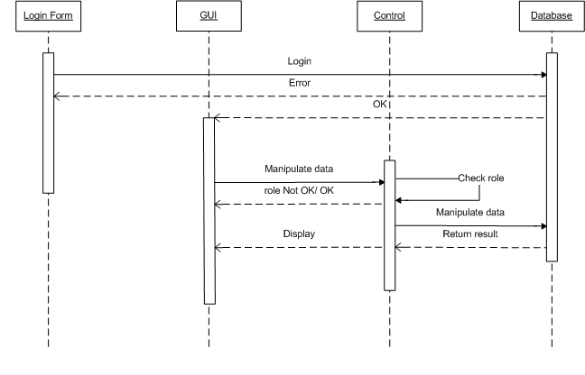

5.2. Select data
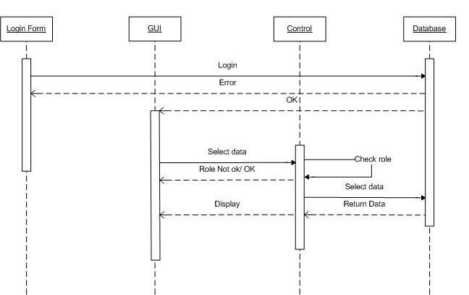

6. User Interface Design
Overview: Keep It Short & Simple is very important attribute of our design. Button has big font size and friendly color. Notification system appears whenever system found that we need it. We just have 2 forms. Other functions are designed as simple popup.
User will be able to access system after the validation of their roles.

6.1. All-customer form

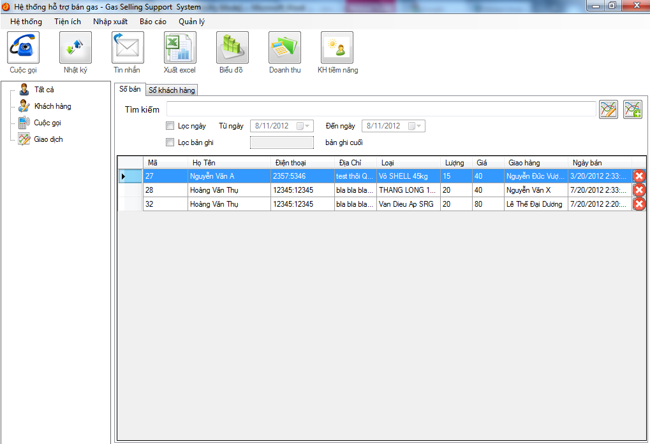

Function | Name | Description
[Hệ thống] | System | System setting and control (Time, modem configuration, bill configuration, backup, employee list, suppliers list, good list)
[Tiện ích] | Utilities | Insert, Update, Delete database. Fake call, data change diary.
[Sổ khách hang] | Customer manager | Remove customer, display customer, export customer list
[sổ bán hang] | Seller Manager | Remove selected sell record, export seller statistic, check sell from date…to date.
[Nhập xuất] | Import/Export | Check, import/ export from supplier, import/ export from itself.
[Báo cáo] | Report | Create report call, sell, employee, customer…
[sửa thông tin khách hàng] | Edit | Edit customer
[Thêm thông tin khách hàng ] | Add | Add customer

6.2. Edit form

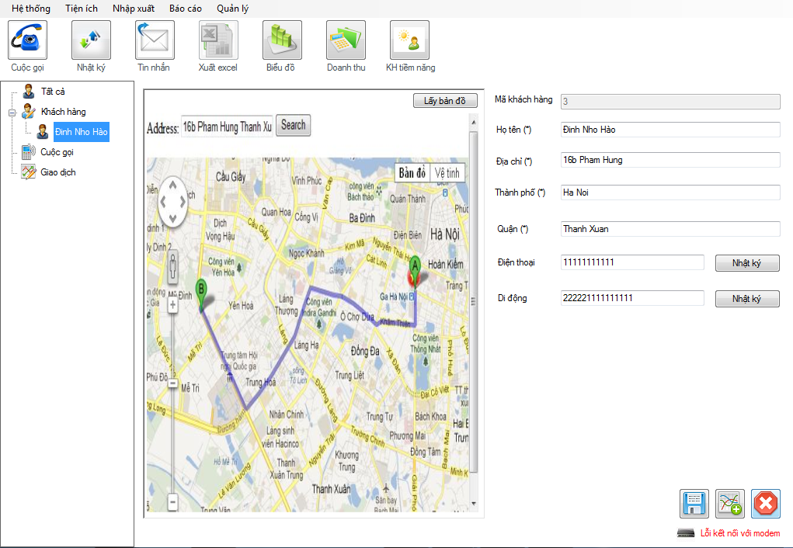
Number | Name | Description
1 | Edit fields | Details of selected customer
2 | Print | Print bill.
3 | Save | Save details to database
4 | Close | Close editing panel and open All customer panel

6.3. Report Import/ Export
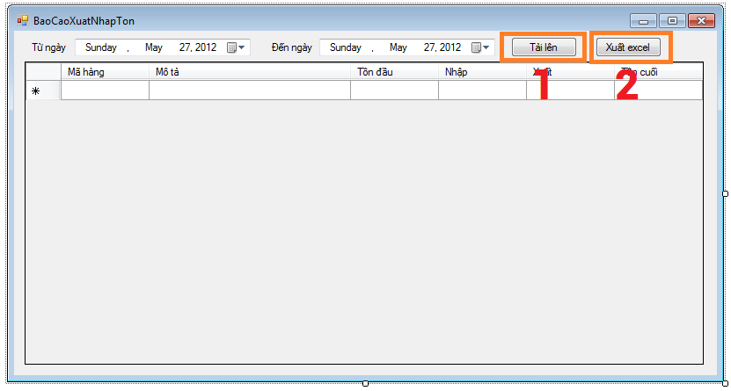

Number | Name | Description
1 | Import | Import from excel
2 | Export | Export to excel

6.4. Sell Statistic

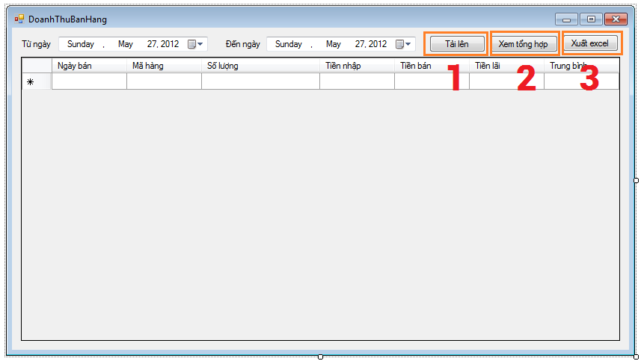

Number | Name | Description
1 | Import | Import from excel
2 | See All | See all sale statistic
3 | Export | Export to excel

6.5. Call diary

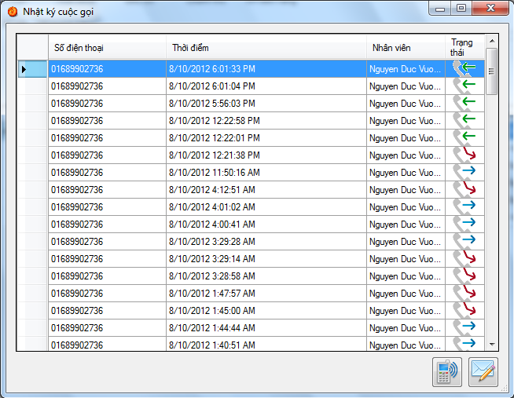

6.6. Sale Statistic and Employee
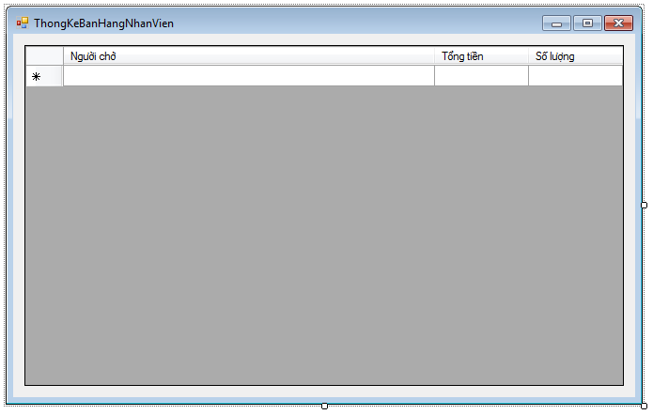

6.7. Setup modem
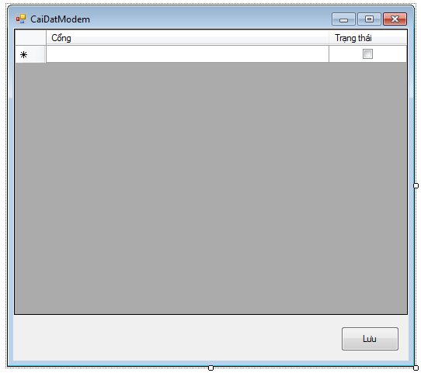

6.8. Supplier list

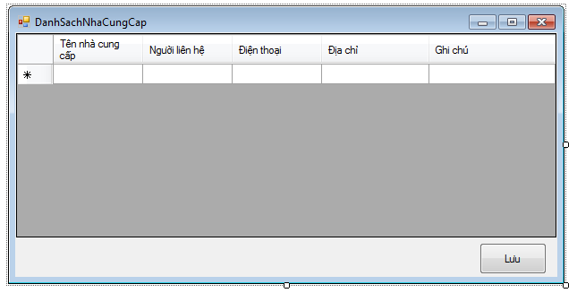

6.9. Employee list
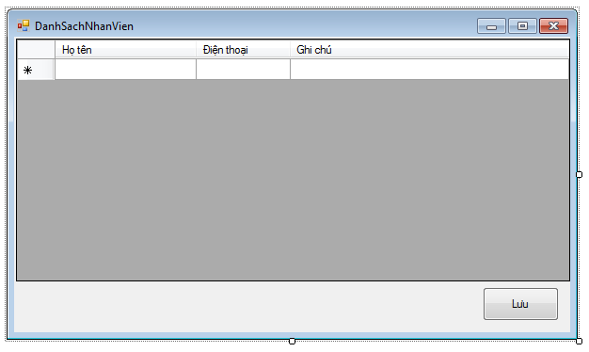

6.10. Import ourselves
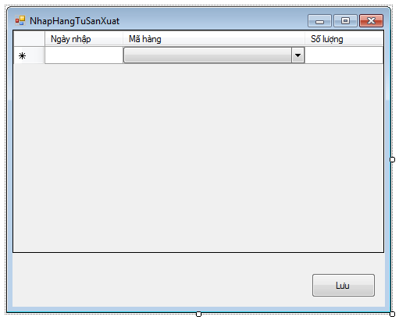

6.11. Import from suppliers
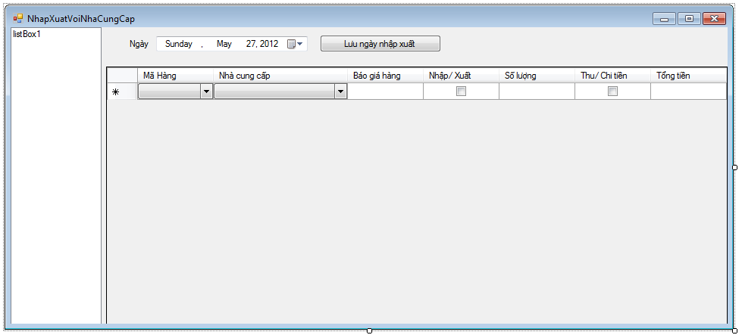

6.12. Check repository

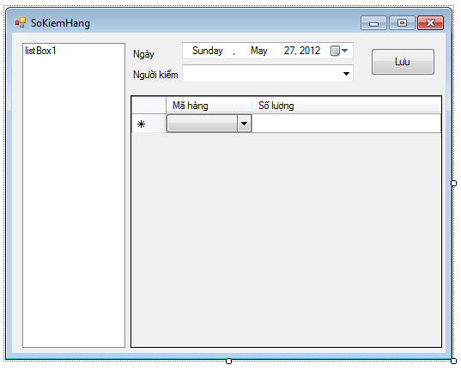

6.13. Notification: appear when someone is calling
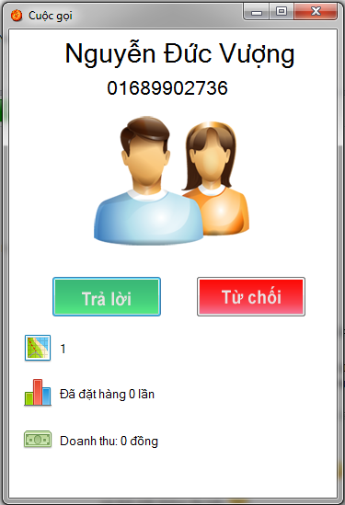

7. Database Design or Data Structures
